
Dhaka International University
Lab Report details:
Lab Report Topic : Find The Max Value Of Three number with conditional operator
Lab Report No : 02
Course Title : Object-Oriented Programming Languages
Course Code : 0613-202

Submitted By: | Submitted To:
S M Nabil Ausaf  Roll: 01  Reg No: CS-D-91-23-124492 | Prof. Md. Abdul Based

Date of Submission: ‎08-‎Oct-‎24

#include<stdio.h>
int maxi (int a, int b,int *c);
int main ()
{
int x,y,z,max;
scanf("%d %d %d",&x,&y,&z);
max=maxi (x,y,&z);
printf("%d",max);
return 0;
}
int maxi (int p,int q, int *r)
{
int m;
m=p>q?(p>*r?p:*r):(q>*r?q:*r);
return m;
}
Objective
The goal if this program to compare 3 Integers (2 by Value, 1 by Reference). Here the program asks the user to input three integers, then uses a function "maxi" which return the maximum of three values.

Components Used
1. Standard Input/Output Library (#include<stdio.h>):
The program uses the standard library to handle input and output, such as "scanf()" for getting input from the user, or `printf()` for displaying the result.
2. Variables:
- int x, y, z: These hold the three input integers which are stored from the user's input.
- int max: To store maximum value amongst those returned by "maxi".
- int m: A local variable inside the function "maxi", which serving for storing the computed maximum.
3. Functions:
- "main()" : This is the function where the flow of the program is controlled. It reads the input values and calls the "maxi" function.
- maxi(int p, int q, int *r): This function takes three parameters : two integers by value (p,q) and one by reference using pointer to r, and will return the biggest of the three values.

4. Pointer (int *r):
The pointer in the function is "maxi", the pointer is used indirectly or by reference to the third integer. It shows how pointers work to modify or retrieve values stored in another location in memory.

5. Ternary Operator:
In the following code , the "maxi" function uses the ternary operator ("condition ? true_value : false_value") to compare the values for determinig the maximum value between the three integers.
6. User Input ('scanf()'):
The function main() utilizes the function scanf() to get input from the user of three integer values and store them in x, y, and z.
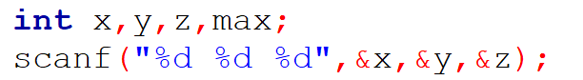
7. Output ('printf()'):
Once the maximum value has been found, the 'printf()' function is used to display the result to the user.
The components work together to achieve the goal of determining and printing the maximum value of three integers.
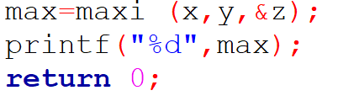
Theory
In this lab, we explore the concept of functions, pointers and conditional statements. This c program solves the problem of finding the maximum value among three integers.

1. Functions:
A function in C is used allows code or make the code modular. Here, the "maxi" function encapsulates the logic of returning the maximum of three numbers. The following is applied by the function:
- Passing values by reference using pointers.
- Returning value from a function.
2. Pointers:
Pointers are variables that store the memory address of another variable. In this program, one of the integers is passed by reference using a pointer ("int *r"). This allows the function "maxi" to access and compare the value stored in 'r' without copying it, making the code more efficient.
3. Ternary Operator:
The ternary operator in C is a compact way of writing conditional statements. The general syntax is in C :
condition? Value_if_true : value_if_false;
In the "maxi" function, the ternary operator is used to compare the three integers and select the maximum value. It allows writing the comparison in a single line, making the code concise and easy to read.
4. Comparison of Values:
The logic for finding the maximum value is implemented using nested ternary operators. The function compares:
- First, whether "p" is greater than "q".
- Then, compares the larger of "p" or "q" to the value of "*r" (the integer passed by pointer) to determine the final maximum value.
5. Input and Output:
The 'scanf()' function reads the input from the user and stores it in the respective variables. The 'printf()' function is used to display the result, which in this case is the maximum of the three numbers.
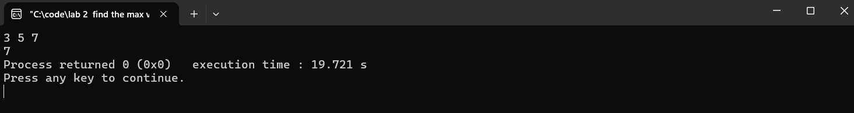

6.Memory Management:
By using pointers, the program avoids copying large data and making it efficient. The pointer also enables direct manipulation of memory, allowing the program to access and modify variables outside the function's scope.
This lab demonstrates the foundational concepts of C programming, including function design, pointers, and conditional logic, which are essential for problem solving and efficient programming. It explain how these elements can be combined to create a function that performs a useful task finding the maximum value of three integers.
Problem/Design Solving Procedure:
Problem:
Design a program that asks a user for three integer values and using a function, identifies the maximum value among the three. This means it needs a function that is capable of comparing such integers and returns the maximum among them. The problem must be solved by passing some integers by value and one by reference using pointers .
Design/Procedure:
Step 1: Define the Main Program Structure
- Begin by including the standard input/output library function (stdio.h)that provides functions like scanf() and printf() for reading input and printing output.
- Then define the main() function which is the entry of this program.
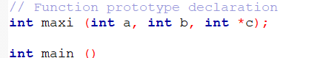

Step 2: Function Prototype Declaration
- Declare a function called 'maxi' that will compare the three integers. This function will take two integers by value and one integer by reference using a pointer. The function should return the largest of the three integers.
- Prototype: int maxi(int a, int b, int *c);
Step 3: Take User Input
- Inside the main() function, declare three integer variables (x, y, and z) to store the values input by the user.
- Then, take three integer inputs from the user using the function scanf().
Step 4: Call to the Comparing Function
Take x and y as input values by value and the address of z, using the pointer &z to the maxi function in order to get the maximum value.Store the result of the maxi function in the variable max.
Step 5: Write the maxi function
Inside the maxi function, compare the two integers that were passed by value p and q, to the integer that was passed by reference *r. Check using the ternary operator:
If p is greater than q, compare p with *r (the dereferenced pointer to r).
q is greater then compare q with *r. Return the greatest number obtained from the comparisons.
Step 6: Result
After calling the maxi function, use the printf() function to print the result (maximum value).
Step 7: Testing the Program and Run the program several times with different integer sets to see that it correctly outputs the maximum of three input values.

Procedure:
#include<stdio.h>
//Function prototype declaration
int maxi (int a, int b, int *c);
int main ()
{
int x, y, z, max;
//Input: Get three integer values from the user
scanf ("%d %d %d",&x,&y,&z);
//Call the maxi function to find the maximum value
max=maxi (x,y,&z);
//Output: Print the maximum value
printf("%d",max);
return 0;

}
//Function definition: Finds the maximum value of three numbers
int maxi (int p,int q, int *r)
{
int m;
//Compare p, q, and the dereferenced value of r
m=p>q?(p>*r?p:*r):(q>*r?q:*r);
return m;
}

Key Steps to Solve the Problem:
- Defining the function structure: The ”maxi” function should be designed to take two integers by value and one by reference for efficient comparisons.
- Using pointers: Passing one of the integers by reference helps explain pointer usage and memory access in C programming.
- Efficient comparisons: The ternary operator is used in order to reduce the logic for finding a maximum value to one line for making the code efficient and brief.

Discussion:
This program will effectively explain the use of functions, pointers and the ternary operator in C programming for the problem of finding the maximum of three integers. The function 'maxi' takes two integers by value and one by reference using a pointer. This shows not only the difference between pass by value and reference but also how pointers can be used to access and modify data out of its scope.
The ternary operator does the work of comparison compactly; hence, the code to find the maximum is succinct. In fact, in general, this makes the code readable and efficient by saving many 'if-else' statements. The program is good in that the logic of comparison has been abstracted away from the main function into one which itself can be much reused and easily maintained.
This program, in its simplicity forms a basic example for understanding some of the concepts of the C language: such as function calls, manipulation of pointers, and conditionals used within this programming to handle more complex problem solving of programming.

